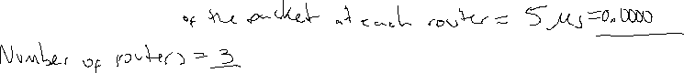



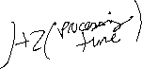

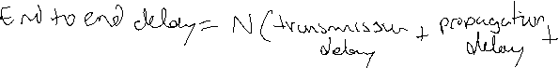



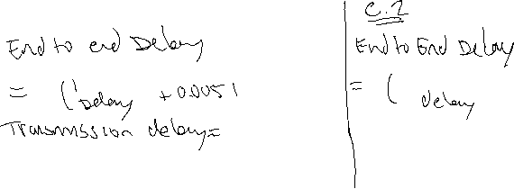

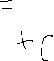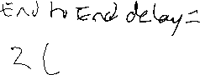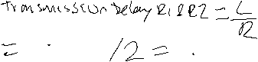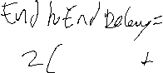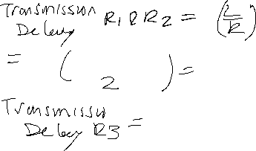



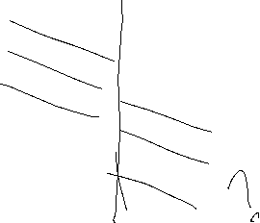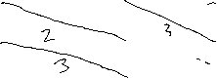



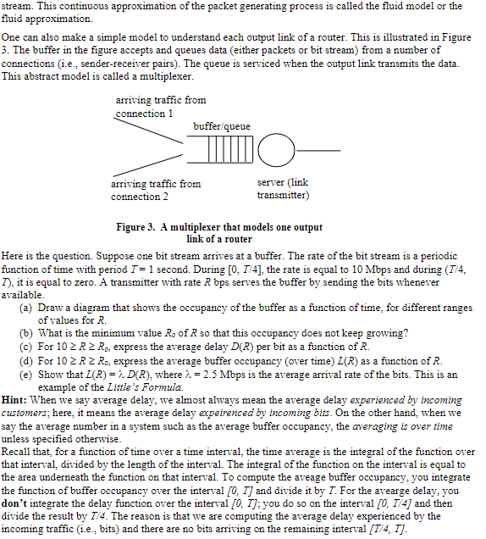

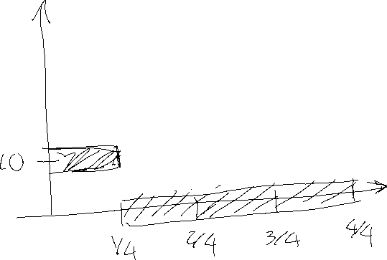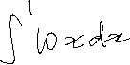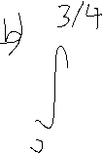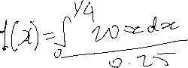

1. A circuit switched network is the best option for this can kind of application, since we know it will run for long periods of time, we know we will have smooth bandwidth requirements. Thus, it is at a steady state, and will have dedicated resources.



1. In this situation we will not need any congestion control mechanism, since the links have sufficient bandwidth to handle the sum of all the application data rates, we have dedicated resources.



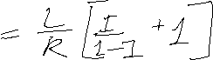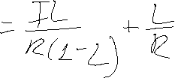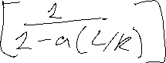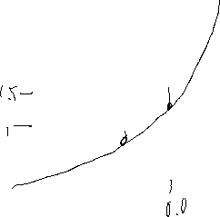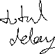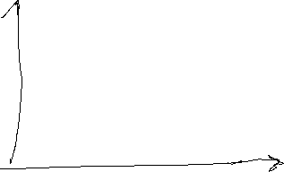

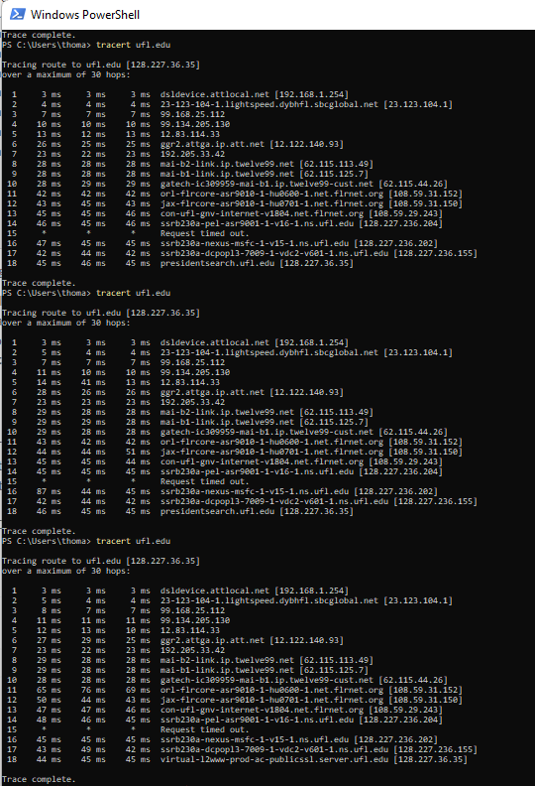

|  |  |  |
| --- | --- | --- |
|  | Average | Standard deviation |
| 1 | 28.21 | 17.69 |
| 2 | 26.89 | 16.71 |
| 3 | 27.89 | 18.81 |

1. There were 18 routes in the path for each of the times. There were no changes
2. 14 ISPs.  Yes, in this experiment the largest delays occurred at peering  
   interfaces between adjacent ISPs

|  |  |  |
| --- | --- | --- |
|  | Average | Standard deviation |
| 1 | 24.38 | 16.19 |
| 2 | 22.15 | 13.99 |
| 3 | 14.08 | 16.25 |

1. There were 13 routes in the path for each of the times. There were no changes
2. 9 ISPs. Yes, in this experiment the largest delays occurred at peering  
   interfaces between adjacent ISPs

